STOCK

MANAGER

v1.0

By: Harguna Sood

(101510028)

(CML-2)

**Table of Contents**

1. **Introduction**
   1. Purpose____________________________________3
   2. Scope______________________________________3
   3. References__________________________________4
   4. Software and Hardware______________________5

1. **Description**
   1. Manual Database____________________________6
   2. Automated Database_________________________8
   3. Overall (FK-PK Realtions)______________________12
   4. Workflow___________________________________13
2. **Benefits________________________________**14
3. **Summary_______________________________**15

**INTRODUCTION**

1. **Purpose**

Days are gone when entries or databases were made manually. Today is about automation, which is considered as a more efficient way method. This product contributes to the same. Stock market is a computer based, fully automated trading system. All transactions and their corresponding records are automatically saved to stock exchange’s database. However, stock-brokers and other shareholders need to keep a record for their own purpose. Generally, they do this by writing them down in a register or a ledger. This makes it a very tedious job. This is the part where this software comes into play.

1. **Scope**

As the name suggests, this software would let a shareholder keep a record of all their transactions. This software basically aims more at requirements of a stock-broker than an individual shareholder as a stock-broker needs to keep track of different clients and their respective transactions. But definitely, it can be used by an individual shareholder. This software can also be used by developers as well as by students for learning purposes.

Thus, this software could be used commercially and even at personal level.

1. **References**

For further details or queries:

Drop an email at: [harguna.sood@gmail.com](mailto:harguna.sood@gmail.com)

Or

Ring a bell at: +91 7307656888

For details about DBMS:

Refer: Simplified Approach To DBMS

For details about Oracle 9i:

Visit: <https://docs.oracle.com/cd/B10501_01/server.920/a96524/toc.htm>

1. **Software and Hardware**

This software is a combination of:

Back-end: Oracle 9i

Front-end: CSS, HTML, Bootstrap

Hardware required:

Network adaptor- To connect with oracle server

Or

Oracle 9i installed- In that case, internet would not be required and user can make his own server

This software being a website would be compatible with any smartphone or laptop or PC.

**DESCRIPTION**

* 1. **Manual Database**

In manual database, records are handwritten as shown:

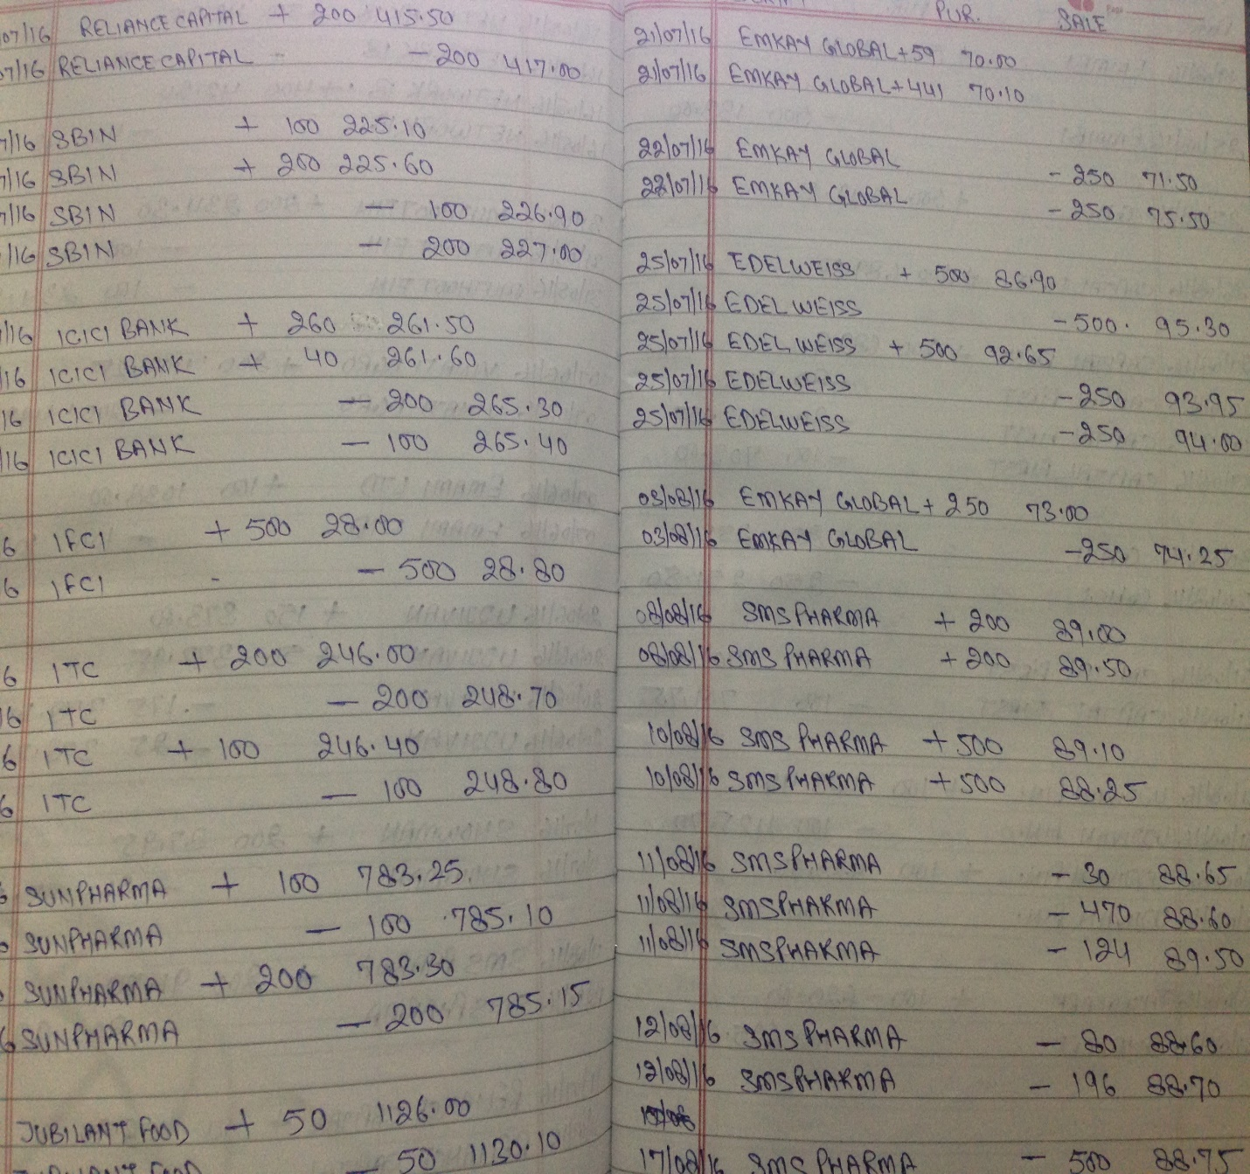

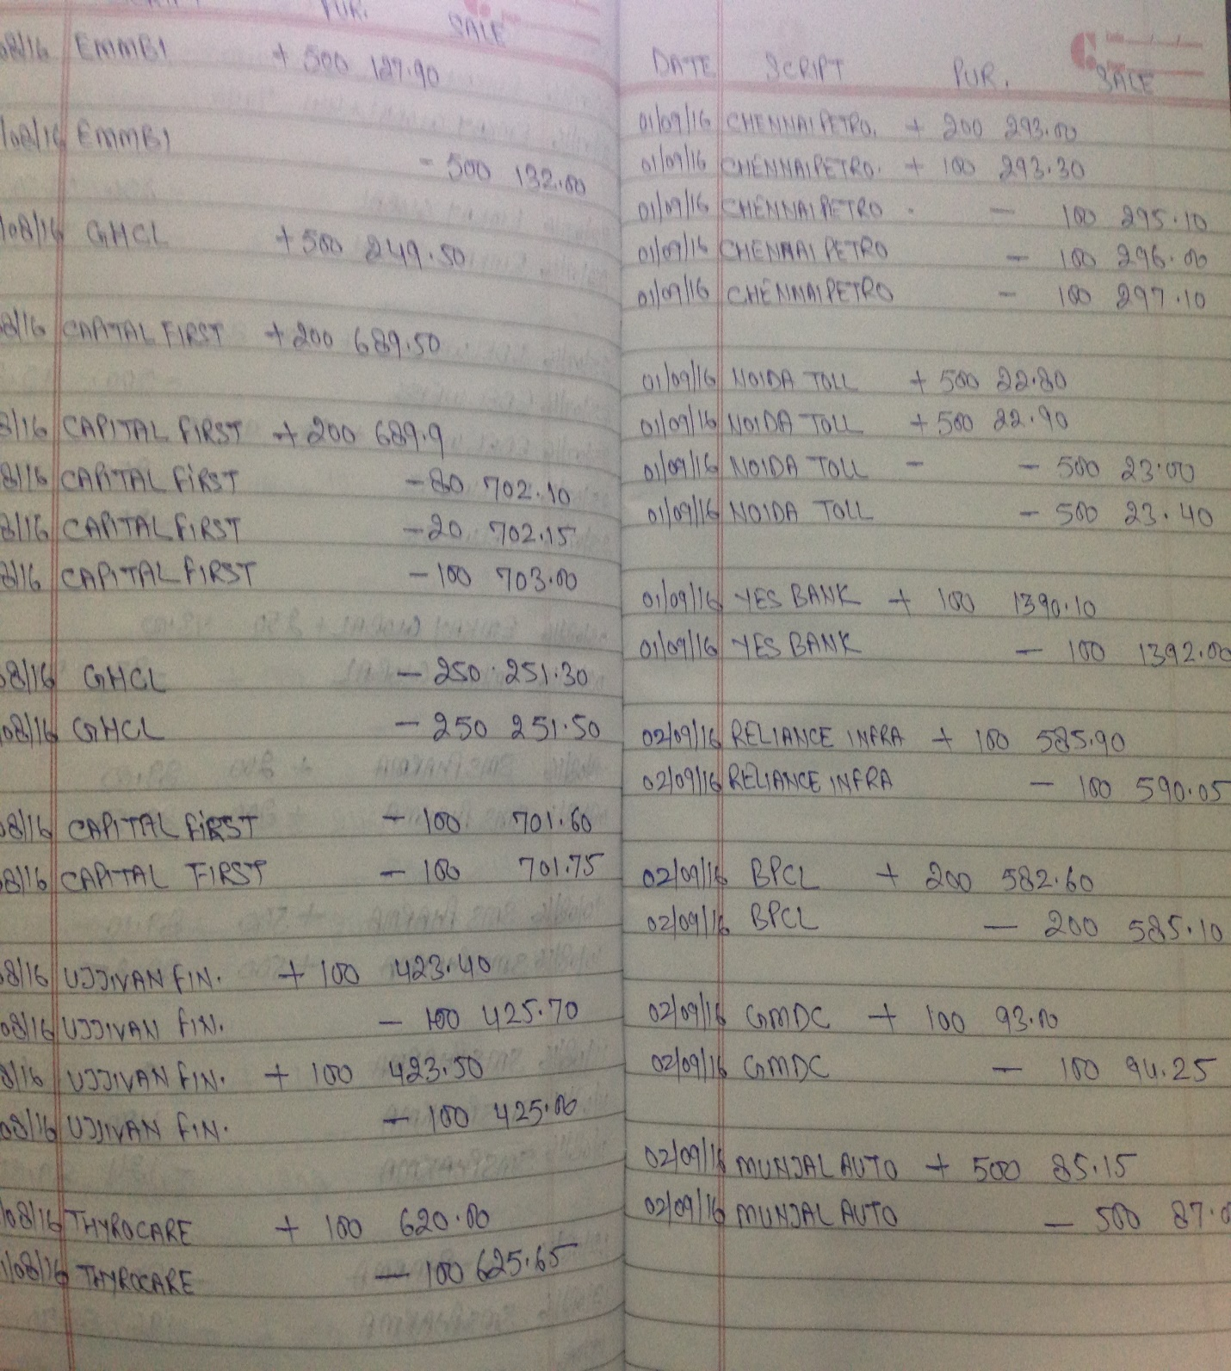

* 1. **Automated Database**

The organization in this software would be as:

**CLIENT** table

|  |  |  |  |  |  |  |  |  |  |
| --- | --- | --- | --- | --- | --- | --- | --- | --- | --- |
| Client_id | Name | Ph_no | Email | Address | Id_prf | Id_prf_no | Pan_no | Acc_no | Dp_id |
|  |  |  |  |  |  |  |  |  |  |

Attributes are: (All the values would be **not null**)

**Client_id** 🡪 Client’s ID (Primary key)

**Name** 🡪 Client’s Name

**Ph_no** 🡪 Client’s Phone Number

-check ( Ph_no >0 and length(Ph_no)=10 )

**Email** 🡪 Client’s email address

**Address** 🡪 Client’s address

**Id_prf** 🡪 Id Proof

-check( id_prf in(‘License’, ’Passport’, ’Adhaar card’, ’Voters card’) )

**Id_prf_no** 🡪 Number on client’s id proof

-check( Id_prf_no >0 )

**Pan_no** 🡪 Client’s Pan card number

-check (Pan_no >0)

**Acc_no** 🡪 Client’s bank account number

-check(Acc_no >0)

**Dp_id** 🡪 Depository Participant Id

Foreign key references DP(Dp_id) on delete cascade

-check(Dp_id >0)

**DP** table

|  |  |  |
| --- | --- | --- |
| Dp_id | Dp_name | Depository |
|  |  |  |

Attributes are: (All the values would be **not null**)

**Dp_id** 🡪 Depository Participant’s Id (Primary key)

**Dp_name** 🡪 Depository Participant’s Name (Unique)

**Depository** 🡪 Name of the depository whose

participants are listed

-check( depository in(‘NSDL’, ‘CDSL’) )

**COMPANY** table

|  |  |  |
| --- | --- | --- |
| Code | Name | Id |
|  |  |  |

Attributes are: (All the values would be **not null**)

**Code** 🡪 Company’s code ( Primary key )

**Name** 🡪 Company’s name (Unique)

**Id** 🡪 Company’s id number (Unique)

(Code is promoted as pk because it is shorter than other two)

**TRANSACTION**  table

|  |  |  |  |  |  |  |  |  |  |  |
| --- | --- | --- | --- | --- | --- | --- | --- | --- | --- | --- |
| T_id | Client_id | Code | Date | Time | Type | Buy_p | Sell_p | Bkg | S_tax | Qty |
|  |  |  |  |  |  |  |  |  |  |  |

Attributes are: (All the values would be **not null** except Buy_p and Sell_p)

**T_id** 🡪 Transaction id (Primary key)

**Client_id** 🡪 Client’s id

Foreign key references CLIENT(Client_id)

on delete cascade

**Code** 🡪 Company’s code

Foreign key references COMPANY(Code)

on delete cascade

**Date** 🡪 Date of transaction

**Time** 🡪 Time of transaction

**Type** 🡪 Type of share

-check ( Type in (‘Cash’, ‘Future’) )

**Buy_p** 🡪 Price at which share was bought

**Sell_p** 🡪 Price at which share was sold

-check (Buy_p is not null or Sell_price is not null)

**Bkg** 🡪 Brokerage

-check(Brokerage >0)

**S_tax** 🡪 Service Tax

-check(S_tax >0)

**Qty** 🡪 Quantity

-check( Qty >0 )

**2.3 OVERALL (FK-PK relations)**

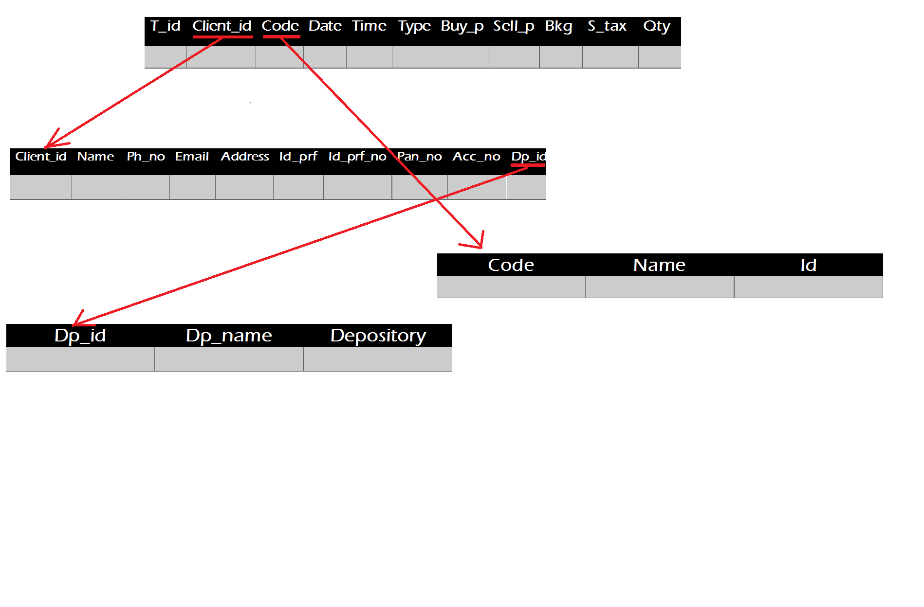

* 1. **WORKFLOW**
* First, stock broker would add the depository participant details in **DP** table to have a master of all allowed Dp details.
* Then, would make a database of all stocks he deals in, in **COMPANY** table for allowed stocks.
* After this, stock broker is good to go and add client details in **CLIENT** table.
* Finally, all is set to make the main database i.e. **TRANSACTION** table. Here, only allowed client_id and code are allowed which provides integrity and consistency of data.
* Admin would be allowed to update **CLIENT, DP, COMPANY** so that in future if a new share or company or client or dp is introduced, it could be added to database without any trouble.

**BENEFITS**

* Functionality and features of this software would be such that it would make stock-broker’s tasks easier and more efficient.
* More data storage
* Faster retrieval of data and easier search
* Data can be updated without any cutting
* Data can be deleted and that space can be reallocated
* Easier study and understanding of data
* Integrity of data as only allowed and correct values can be enetered
* Consistency of data as same combination of data can’t be added
* Sharing of data can take place between machines
* Easier backup and recovery as only a single file is to be protected
* Data independence

**SUMMARY**

This product has great usability for a stock player and especially stock-brokers. Its user-friendly feature makes it even more special. Along with that, it has all attributes that a stock-broker may need. It also gives power only to the admin to add or delete records. Overall, it has more advantages than manual methods. Also, on some level it, would help to save paper and thus, trees. This product is another contribution to automation in the field of stock market.